Booking of Space at La Place
Prepared by: Yee Shiun
Date: 3 Dec 2025
1. Fill in the Booking Form
Students must complete the La Place booking form with accurate information.
Link: https://docs.google.com/forms/d/e/1FAIpQLSebZ4pnfhBg3Z0f3xZjk1IFZaSbziVmlWDnkgRd5PF6NwYcrw/viewform

2. Email Student Life Division (SLD)
After submitting the form, email Ms. Chong at yeeshiun.chong@qiu.edu.my to inform SLD of your request.
Please include key event details such as:
- Purpose of the booking
- Items to be sold or promoted
- Brief activity description
3. Verification by SLD
SLD will check with the Person-in-Charge (PIC) of La Place to verify the availability and approve the booking.
4. Confirmation Email
Once confirmed, SLD will reply via email with the booking status and any additional instructions.
5. Table Usage Rules
- Students may use the designated table provided (refer to the Appendix below).
- Setup must follow the arrangement shown in the demonstration image.
- After use, students must return the table to its original position.
- Students must clean up the area and ensure the space is left tidy after use.

Appendix 1

- You may use the table as attached in the picture.
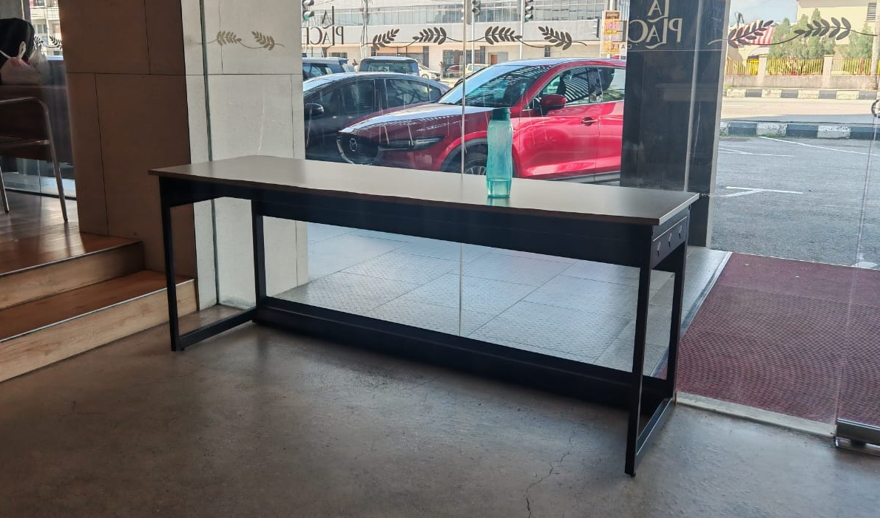

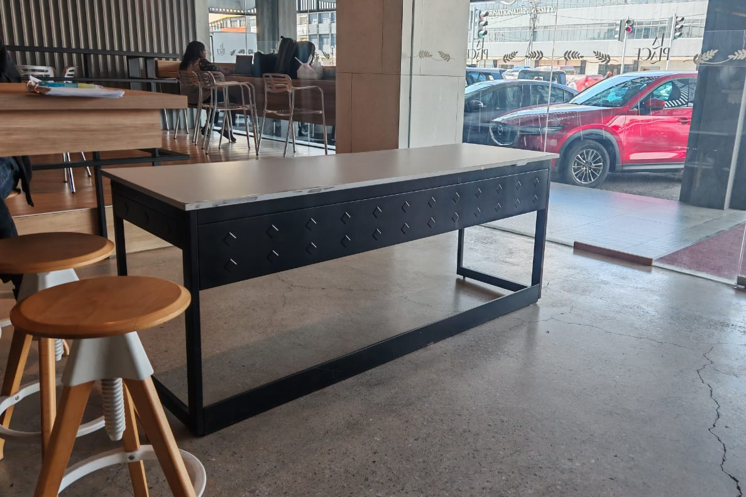
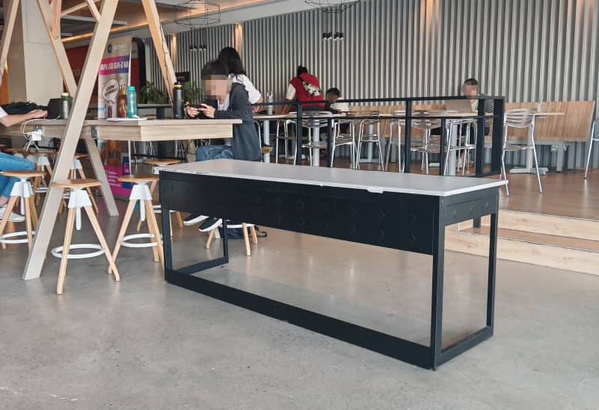
- Arrange the table as shown in the picture below. Please make sure there is a walkway for the students to pass through.

